23CSE111

OBJECT ORIENTED PROGRAMMING

LAB REPORT



Department of Computer Science Engineering
Amrita School of Computing
Amrita Vishwa Vidyapeetham, Amaravati Campus.

Verified by Name: G. Pooja Priyanka
Roll no: AV.SC.U4CSE24107

S.No |  | Date | Page No | Signature
LAB-1
a | How to download JDK-21 in your PC
b | Set environment variables in your PC
c | Checking of JDK-21 version
d | Write a simple java program to about an student

WEEK-1
1) Explain the process of Installing JDK (Java Development Kit)
Download:
- Open web browser and search “Oracle Java”.
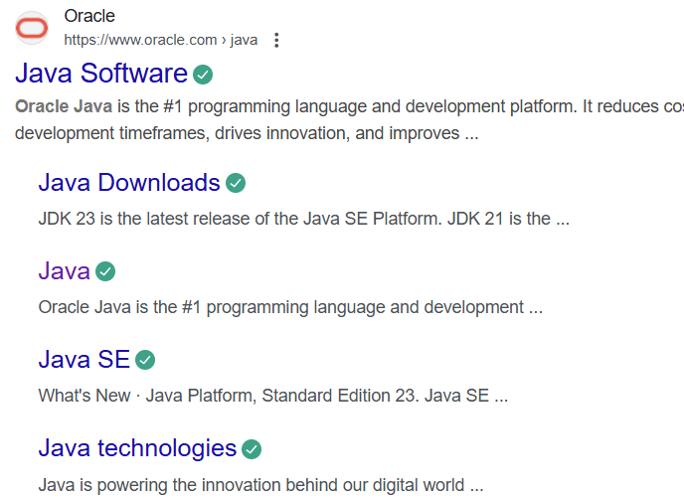
- Open the first website oracle.
- Click on “download Java” in the oracle interface.
- Select the version you want to download (version JDK21).
- Select the Operating System (OS) of your PC and click on the link “x64 installer” to download.
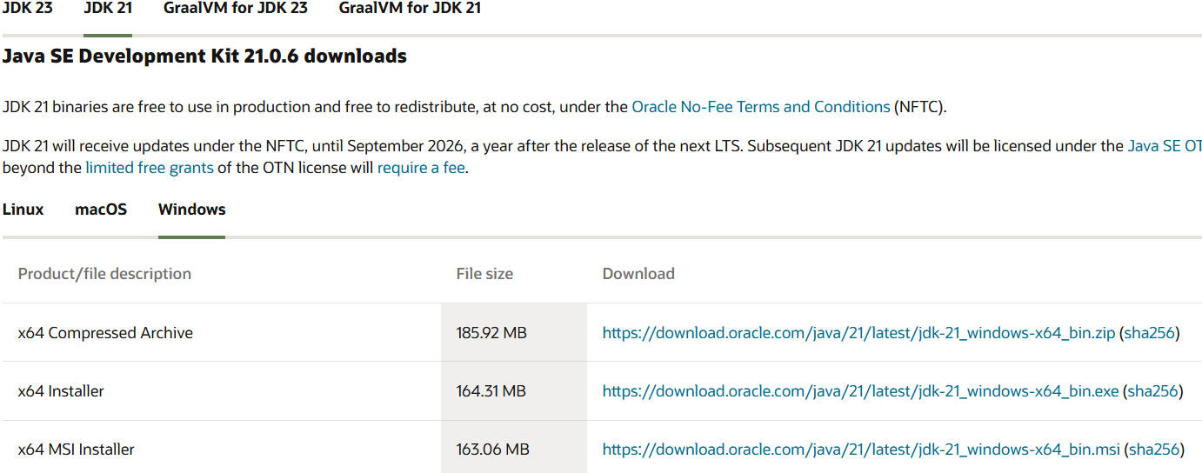
Installation:
  - Once downloaded, run the installer.
  - Follow the instructions and keep clicking "Next" until it's done.
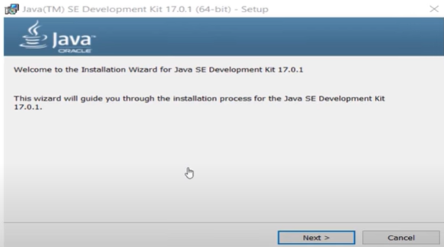
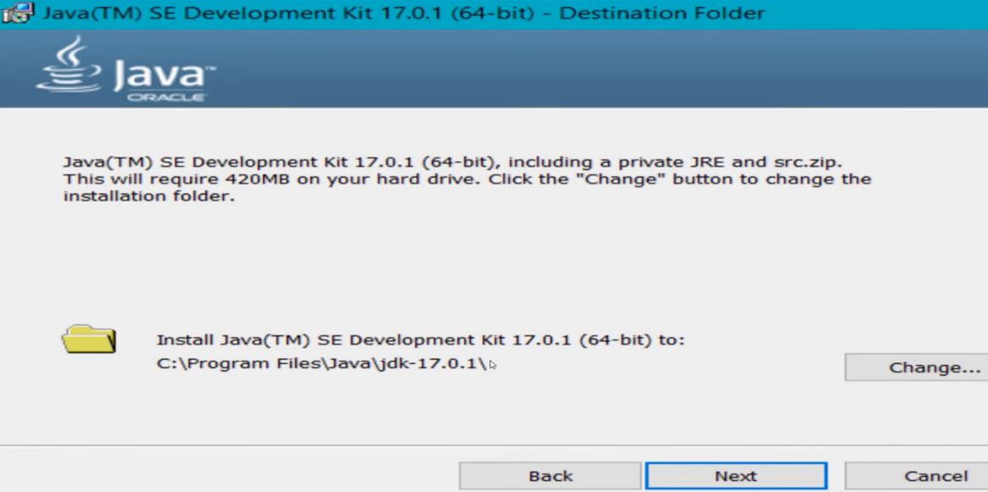

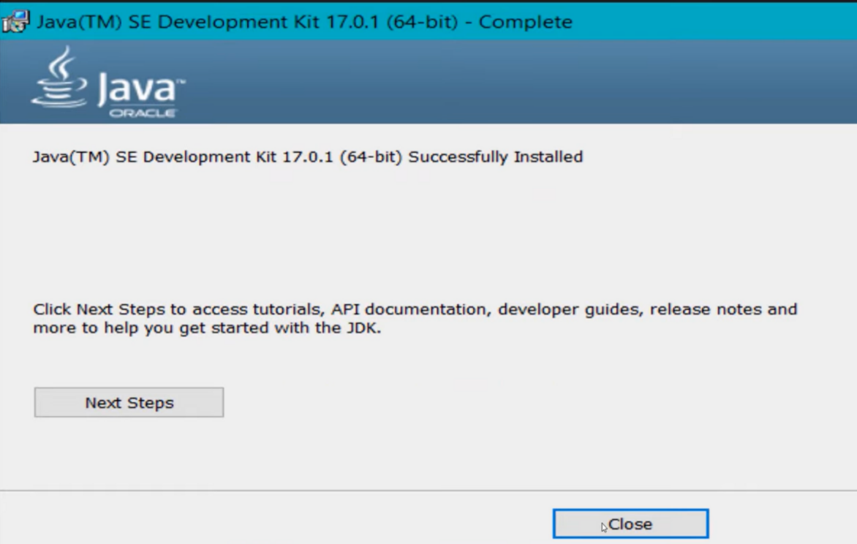
Set Environment Variables (Windows):
  - Open file explorer, then right click on This PC next select on properties then it will take you to the settings app then click on advanced system settings and then
click on Environment Variables.
  - Click New under System Variables:
    - Set Variable name as: java
    - Variable value: The folder address where JDK is installed ("C:\Users\ASUS\Downloads\jdk-21_windows-x64_bin.exe")
- Find Path under System Variables, click Edit, and add the path of the jdk-21(C:\Program Files\Java\jdk-21\bin)
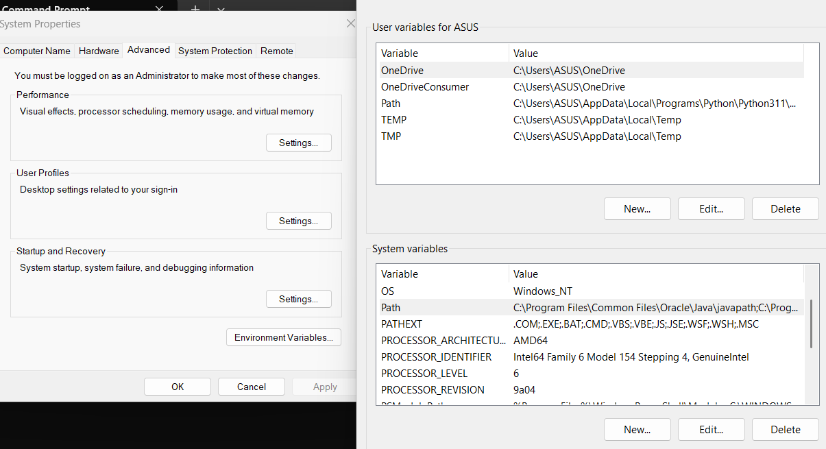
Checking of JDK Version:
- Open Command Prompt:
  - Press win+R, type cmd, and press Enter.
- Check Version:
  - Type java --version and press Enter.
  - Type javac --version and press Enter.
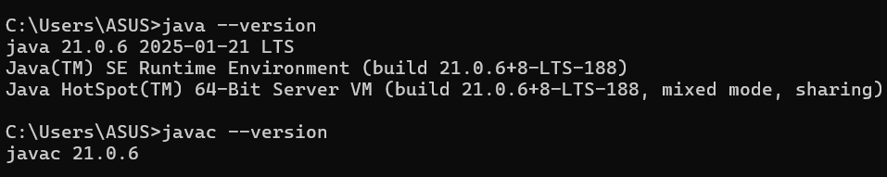

PROGRAMS:

1)Write a Java program to print the message “Welcome to Java Programming.”

CODE:
class Hello{
public static void main(String[] args){
System.out.println("Hello, World!");
}
}

OUTPUT:
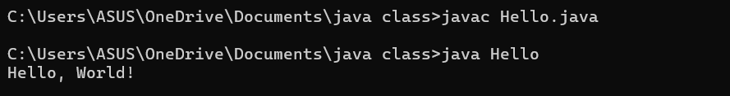
ERRORS: Found none

2) Write a Java Program that prints Name, Roll No, Section of a student.

CODE:
class student{
public static void main (String[] args){
System.out.println("Name: Pooja Priyanka");
System.out.println("Section: CSE-B");
System.out.println("Roll No: 24107");
}
}

OUTPUT:
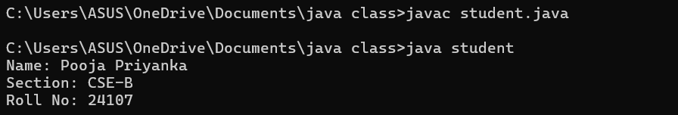

ERROR TABLE:
Code Error | Code rectification
1)writing small “s”in place of”S”  In system.out.println().  2)not giving strings to the name and section. | 1)code is rectified by keeping capital “S”.  2)Giving strings to name and section.

IMPORTANT POINTS:
1)System.out.println(“this string will be printed”) – this line of code is used to print any string.
2)if you want to save your java file as student then “class student { “ should be written”}

WEEK-2
3)write a java program on largest of 3 numbers using ternary operators.
CODE:
import java.util.Scanner;
class largest_number{
public static void main(String[] args){
Scanner input = new Scanner(System.in);
System.out.println("enter the first number:");
int a=input.nextInt();
System.out.println("enter the second number:");
int b=input.nextInt();
System.out.println("enter the third number:");
int c=input.nextInt();
int largest_number = ((a > b && a > c)? a: (b > a && b>c)?b :c);
System.out.println(" Largest number among three is:" + largest_number);
}
}
OUTPUT:
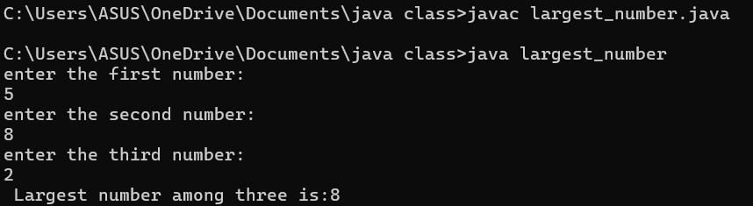
ERROR:
error | rectification
For root in java we  don’t use **. | Use Math.sqrt statement.  Double area=Math.sqrt(x);
2)write a java program for factorial of a number.
CODE:
import java.util.Scanner;
class factorial {
public static void main(String[] args) {
Scanner f=new Scanner(System.in);
System.out.println("enter the number: ");
int number=f.nextInt();
long factorial = 1;
for(int i = 1; i <= number; i++){
factorial *= i;
}
System.out.println("Factorial of " + number + " is: " + factorial);
}
}
OUTPUT:
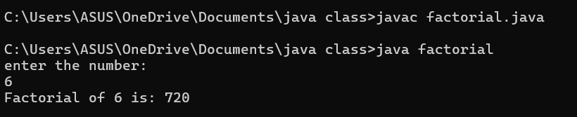
ERROR:
Code Error | Code rectification
- While using for iteration, not giving the conditions correctly.  - Declaring the data type as double instead of int. | - We should give iterative statements correctly.  - We should give the data type as int for integers.

3. write a java program on Fibonacci series.
CODE:
import java.util.Scanner;
class fibonacci {
public static void main(String[] args) {
Scanner input = new Scanner(System.in);
System.out.println("enter the number of terms : ");
int n = input.nextInt();
int f0 = 0, f1 = 1;
System.out.println("Fibonacci Series up to " + n + " numbers:");
for (int i = 1; i <= n; ++i) {
System.out.print(f0+ " ");
int fn = f0 + f1;
f0 = f1;
f1 = fn;
}
}
}
OUTPUT:
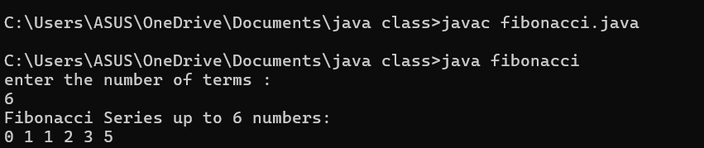
ERROR:
Code Error | Rectification
1.While using for iteration, not giving the conditions correctly  2.Declaring the data type as double instead of int. | 1.We should give iterative statements correctly.  2.We should give the data type as int for integers.

4.a) Write a program in java for converting temperature from celsius to fahrenheit.
CODE:
import java.util.Scanner;
class TemperatureConversion {
public static void main(String[] args) {
Scanner input = new Scanner(System.in);
System.out.print("Enter temperature in Celsius: ");
float ctemp = input.nextFloat();
float ftemp = (ctemp * 9 / 5) + 32;
System.out.println("Temperature in Fahrenheit: " + ftemp);
}
}
OUTPUT:
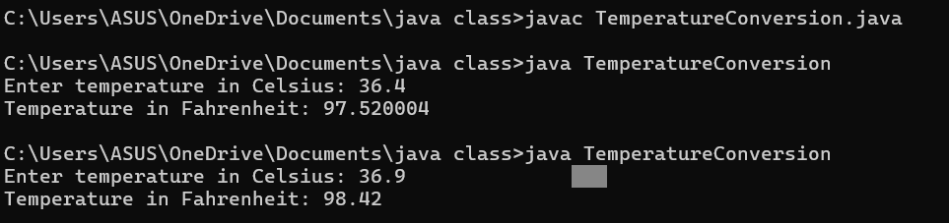
ERROR:
Code Error | Rectification
1.While printing the variable not giving + sign  2. Not closing the scanner. | 1.We should give correct indentation.  2.Closing the scanner is must.

IMPORTANT POINTS:
1.The formula to convert a Celsius to Fahrenheit is
Fahrenheit = (Celsius*9/5)+32.
2.The line “Scanner input = new Scanner(System.in),” tends to create a new Scanner object named “input” that reads input from the standard input stream (System.in), like keyboard.

4.a) Write a program in java for converting temperature from Fahrenheit to celsius.
CODE:
import java.util.Scanner;
class TemperatureConversion1 {
public static void main(String[] args) {
Scanner input = new Scanner(System.in);
System.out.print("Enter temperature in Fahrenheit: ");
float ftemp = input.nextFloat();
float ctemp=(ftemp-32)*5/9;
System.out.println("Temperature in Celsius: " + ctemp);
}
}
OUTPUT:
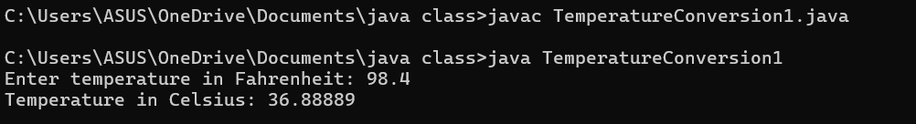
ERROR:
Code Error | Rectification
1.While printing the variable not giving + sign  2. Not closing the scanner. | 1.We should give correct indentation.  2.Closing the scanner is must.

IMPORTANT POINTS:
1.The formula to convert a Fahrenheit to Celsius is
Celsius = (Fahrenheit-32)*5/9
2.The line “Scanner input = new Scanner(System.in),” tends to create a new Scanner object named “input” that reads input from the standard input stream (System.in), like keyboard.

5) write a java program for area of rectangle
CODE:
import java.util.Scanner;
class AreaRectangle{
public static void main(String[] args){
Scanner input = new Scanner(System.in);
System.out.println("enter length:");
double length = input.nextDouble();
System.out.println("enter width:");
double width = input.nextDouble();
double area = length*width;
System.out.println("Area is "+area);
}
}
OUTPUT:
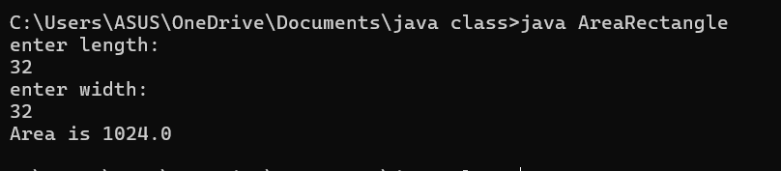
ERROR:
Code Error | Rectification
1.While using for iteration, not giving the conditions correctly.  2.Declaring the data type as double instead of int. | 1.We should give iterative statements correctly.  2.We should give the data type as int for integers.

6)write a java program on calculating simple interest.
CODE:
import java.util.Scanner;
class SimpleInterest {
public static void main(String[] args) {
Scanner input = new Scanner(System.in);
// Reading principal amount,time period,rate of interest from user
System.out.print("Enter the principal amount: ");
double principal = input.nextDouble();
System.out.print("Enter the rate of interest: ");
double rate = input.nextDouble();
System.out.print("Enter the time period (in years): ");
double time = input.nextDouble();
// Calculating simple interest
double simpleInterest = (principal * rate * time) / 100;
// Displaying the simple interest
System.out.println("The simple interest is: " + simpleInterest);
}
}
OUTPUT:
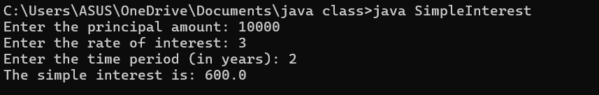
ERROR:
Code Error | Code rectification
1.writing small “S” in place of ”S” in system.out.println()  2.not giving strings to the name and section | 1.code is rectified by keeping capital “S”  2.Giving strings to name and section

WEEK-3
1)write a java program with following instructions:
- Create a class with name car.
- Create 4 attributes named(colour,brand,fueltype,mileage).
- Create 3 methods named(start,stop,service).
- Create 3 objects named c1,c2,c3.
- Create a constructor with parameters colours,brand,fueltype,mileage.
CODE:
public class car1 {
// Attributes
String color;
String brand;
String fuelType;
float mileage;

// Constructor with parameters
car1(String color, String brand, String fuelType, float mileage) {
this.color = color;
this.brand = brand;
this.fuelType = fuelType;
this.mileage = mileage;
}

// Default constructor
car1() {
System.out.println("Welcome to the store!");
}

// Declaring methods
public void start() {
System.out.println("The car is started");
}

public void stop() {
System.out.println("The car is stopped");
}

public void service() {
System.out.println("The car is serviced");
}

// Main method
public static void main(String[] args) {
// Using the default constructor
car1 c1 = new car1();
c1.color = "Red";
c1.brand = "Kia";
c1.fuelType = "Diesel";
c1.mileage = 24;

// Displaying the attributes
System.out.println("Color: " + c1.color);
System.out.println("Brand: " + c1.brand);
System.out.println("Fuel Type: " + c1.fuelType);
System.out.println("Mileage: " + c1.mileage);

car1 c2 = new car1();
c2.color = "black";
c2.brand = "hyundai";
c2.fuelType = "Diesel";
c2.mileage = 20;

// Displaying the attributes
System.out.println("Color: " + c2.color);
System.out.println("Brand: " + c2.brand);
System.out.println("Fuel Type: " + c2.fuelType);
System.out.println("Mileage: " + c2.mileage);

car1 c3 = new car1();
c3.color = "grey";
c3.brand = "BMW";
c3.fuelType = "Diesel";
c3.mileage = 30;

// Displaying the attributes
System.out.println("Color: " + c3.color);
System.out.println("Brand: " + c3.brand);
System.out.println("Fuel Type: " + c3.fuelType);
System.out.println("Mileage: " + c3.mileage);
}
}

OUTPUT:
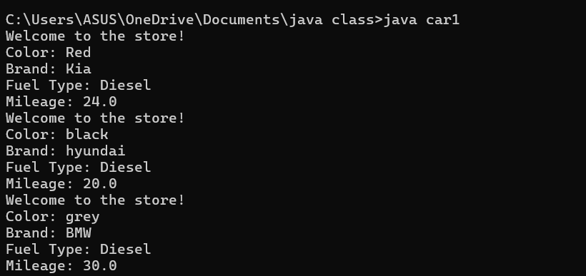
ERROR:

2) create a class named back account with methods deposit and withdraw where the deposit method should accepts a parameter and when this method is called the deposited amount should be added to the current balance in addition to that when a with draw method is called it has to verify whether the withdraw amount is less-than the current balance if not displaying a message saying that there are insufficient funds. use the constructor to display the details of the costumer (name,account number, IFSC,branch) atleast 2 costumers as objects c1, c2.
CODE:
public class bank {
// Attributes
String name;
String accountNumber;
String ifsc;
String branch;
double currentBalance;

// Constructor to initialize customer details
bank(String name, String accountNumber, String ifsc, String branch, double currentBalance) {
this.name = name;
this.accountNumber = accountNumber;
this.ifsc = ifsc;
this.branch = branch;
this.currentBalance = currentBalance;
System.out.println("Account created for " + name);
System.out.println("Account Number: " + accountNumber);
System.out.println("IFSC Code: " + ifsc);
System.out.println("Branch: " + branch);
System.out.println("current Balance: " + currentBalance);
}

// Method to deposit money
public void deposit(double amount) {
if (amount > 0) {
currentBalance += amount;
System.out.println("Deposited: " + amount);
System.out.println("New Balance: " + currentBalance);
} else {
System.out.println("Invalid deposit amount.");
}
}

// Method to withdraw money
public void withdraw(double amount) {
if (amount > 0 && amount <= currentBalance) {
currentBalance -= amount;
System.out.println("Withdrawn: " + amount);
System.out.println("New Balance: " + currentBalance);
} else {
System.out.println("Invalid withdrawal amount.");
}
}

// Method to display account details
public void displayAccountDetails() {
System.out.println("Name: " + name);
System.out.println("Account Number: " + accountNumber);
System.out.println("IFSC Code: " + ifsc);
System.out.println("Branch: " + branch);
System.out.println("Current Balance: " + currentBalance);
}

public static void main(String[] args) {
// Creating c1
bank c1 = new bank("pooja", "123456789", "IFSC1", "Branch1", 5000.0);
c1.deposit(2000.0);
c1.withdraw(3000.0);
c1.withdraw(5000.0);

// Creating c2
bank c2 = new bank("priyanka", "987654321", "IFSC2", "Branch2", 10000.0);
c2.deposit(5000.0);
c2.withdraw(7000.0);
c2.withdraw(9000.0);
}
}
OUTPUT:
